2.5 Logical View of System

Introduction
The logical view of the Online Tutor Marketplace system illustrates how different architectural layers interact to process user requests and manage system operations efficiently. The system follows a three-tier architecture consisting of the Presentation Layer, Application Layer, and Data Layer. This layered architecture improves scalability, maintainability, security, and overall system performance by separating user interaction, business logic, and data management into independent components.
The logical architecture supports major system functionalities including tutor searching, booking management, messaging, AI-based tutor recommendations, and administrative operations.
Three-Tier Architecture
The Online Tutor Marketplace system follows a three-tier architecture model consisting of:
• Presentation Layer
• Application Layer
• Data Layer
Each layer performs specific responsibilities within the overall system architecture.
Presentation Layer
The Presentation Layer represents the frontend user interface of the system and is responsible for all user interactions. This layer allows students, tutors, and administrators to access system functionalities through web-based interfaces.
The Presentation Layer includes:
• Login and Registration Interface
• Student Dashboard
• Tutor Dashboard
• Tutor Search Interface
• Tutor Profile Page
• Booking Interface
• Messaging Interface
• AI Recommendation Interface
• Admin Dashboard
Users interact with the system through this layer by submitting requests such as searching tutors, booking sessions, sending messages, and managing profiles.
The frontend interface is designed using HTML, CSS, JavaScript, and Figma-based UI design principles to ensure responsive and user-friendly interaction across different devices and browsers.
Application Layer
The Application Layer represents the backend processing and business logic of the system. This layer receives requests from the Presentation Layer, validates user input, processes system operations, and communicates with the database layer.
The Application Layer performs the following operations:
• User authentication and authorization
• Tutor search processing
• Booking request management
• Messaging functionality
• Review and rating processing
• Session management
• AI recommendation processing
• Administrative management operations
The Application Layer acts as the intermediary between the frontend interface and the database system. It ensures secure processing of requests and maintains overall system functionality.
The Application Layer also communicates with the OpenAI API to generate intelligent tutor recommendations based on user learning requirements and preferences.
Data Layer
The Data Layer is responsible for storing, managing, and retrieving all system data. This layer contains the database management system and ensures secure handling of platform information.
The Data Layer stores:
• User information
• Student profiles
• Tutor profiles
• Booking records
• Messages and chat history
• Reviews and ratings
• AI recommendation-related data
The database structure uses primary keys and foreign keys to maintain relationships between entities and ensure data consistency.
The Data Layer supports reliable data retrieval, transaction management, scalability, and long-term system maintenance.
System Interaction Flow
1. Users interact with the Presentation Layer through the frontend interface.
2. User requests are sent to the Application Layer for validation and processing.
3. The Application Layer communicates with the Data Layer to retrieve or store information.
4. The Data Layer returns requested data to the Application Layer.
5. The processed results are returned to the Presentation Layer and displayed to users.
6. AI-related requests are processed through the OpenAI API integration within the Application Layer.
This communication structure ensures efficient system operation, secure request handling, and reliable data processing.
Diagram Explanation
The logical view diagram illustrates how the three-tier architecture supports communication between the frontend interface, backend processing modules, and database system within the Online Tutor Marketplace platform.
The Presentation Layer handles user interaction and forwards requests to the Application Layer. The Application Layer processes business logic, validates requests, and communicates with the Data Layer to retrieve or update information. The OpenAI API integration within the Application Layer supports AI-based tutor recommendation functionalities.
The layered architecture improves system scalability, maintainability, performance, and secure data management while supporting all major functionalities of the platform.
The proposed logical architecture provides a structured and scalable foundation for the Online Tutor Marketplace system by separating user interaction, backend processing, and data management into independent layers.

Logical View Diagram
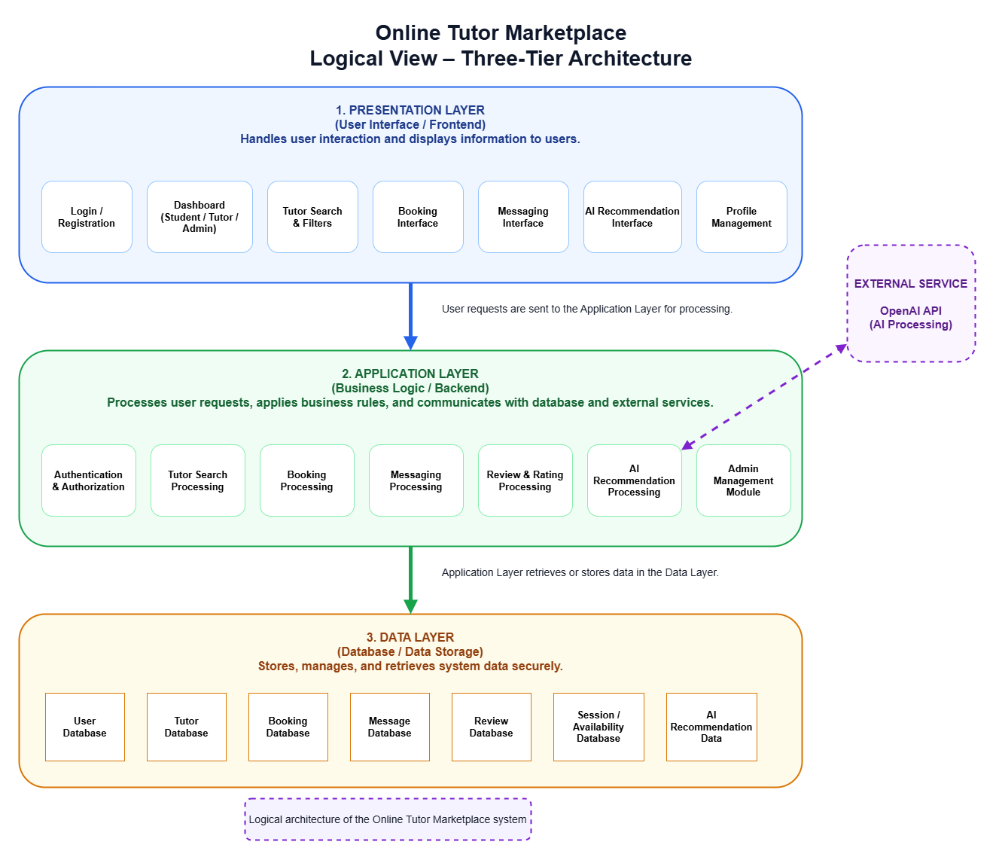
Figure 2.5: Logical View – Three-Tier Architecture of Online Tutor Marketplace System

